EcoMart Relational Database Design
A. Scenario 2 - EcoMart

A1: Business Problem: The EcoMart company faces challenges in managing and analyzing large-scale sales data across various regions, countries, and product categories. The current manual process is time-consuming, prone to errors, and lacks the scalability to accommodate growing data volumes. A database solution is essential to streamline data storage, enable efficient querying, and generate actionable insights.

A2: Proposed Data Structure: The proposed data structure includes three core tables—Categories, Products, and Transactions—each designed to store specific attributes. These tables are interlinked through primary and foreign keys, ensuring data consistency and enabling detailed analysis.

A3: Justification for Database Solution: A relational database offers scalability, data integrity, and efficient query performance. It eliminates redundancy through normalization, supports large-scale data processing, and provides a robust platform for advanced analytics. By using PostgreSQL, EcoMart can implement a cost-effective, reliable, and scalable solution.

A4. Usage of Business Data: The business data will be used to analyze sales trends by region and product category, monitor stock levels, evaluate revenue performance, and optimize order fulfillment. It will also support decision-making through real-time reporting and analytics.

B. Logical Data Model

The logical data model represents the structure of the database, including entities, attributes, and relationships. It ensures data is organized efficiently, adheres to normalization standards, and supports seamless querying and analysis.

Entities in the model include Categories, Products, and Transactions. Each entity contains attributes tailored to its role, such as category_name, price, and order_date. Relationships between tables ensure data integration, such as the one-to-many relationship between Categories and Products.
Entities and Attributes:
- Categories: category_id, category_name, region, and country.
- Products: product_id, category_id, price, and stock.
- Transactions: transaction_id, product_id, order_date, ship_date, quantity, and total_price.

Relationships:
- Categories → Products: One category can have multiple products.
- Products → Transactions: One product can have multiple transactions.
Normalization:
The design adheres to 3NF, ensuring no redundant data and maintaining data integrity.

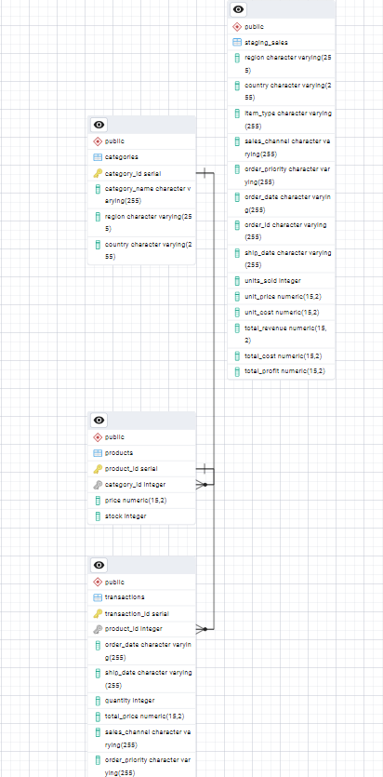

C. Database Objects and Storage

The database consists of core objects like tables, indexes, and relationships designed to store and integrate data effectively. Tables represent entities, with attributes optimized for storage efficiency. For instance, “NUMERIC” is used for monetary values, while “VARCHAR” handles textual data. Indexes are automatically created for primary and foreign keys to optimize query performance.

D. Scalability
The database design addresses scalability concerns to handle increasing data volumes and user demands. Key strategies include indexing for optimized query performance, particularly on fields like “order_date” and “region”. Normalization minimizes redundancy, enhancing data consistency and storage efficiency. This makes data easier to scale than it was previously, and no need to go through thousands of rows of data.

E. Privacy and Security

Strong privacy and security measures are built into the database design to ensure compliance with regulations and protect sensitive information. Encryption safeguards data both at rest and in process, preventing unauthorized access. The company can also require audit logging and 2FA as an added layer of security precautions. Additionally, input validation is implemented to protect against SQL attacks, which will assist in maintaining the database’s integrity.

F. Implementation Through pgAdmin
F1: Creation of Database:
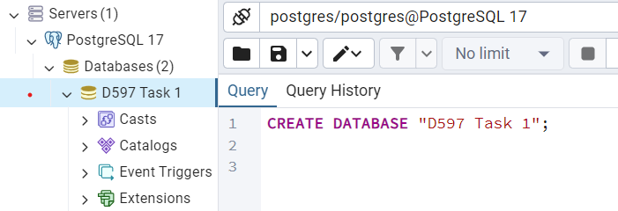

F1: Creation of Tables:
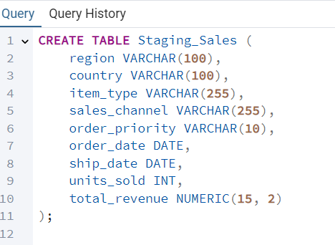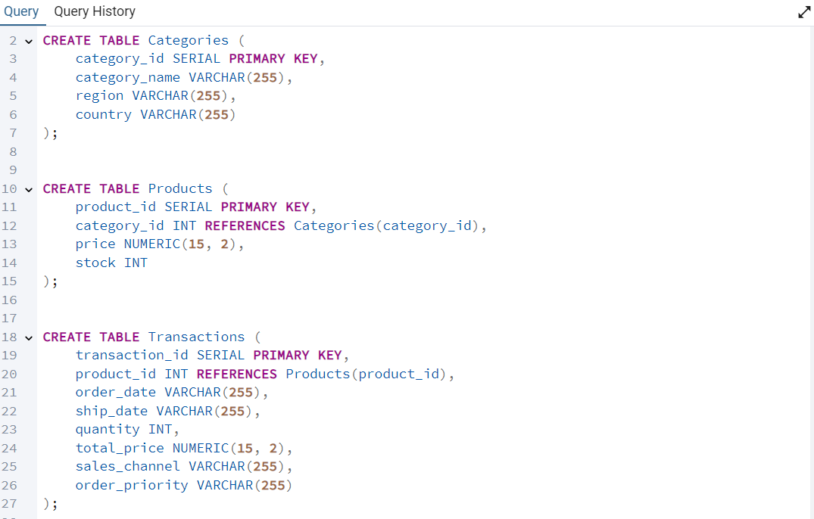
F2. Data import from “Staging Table” to respective tables:
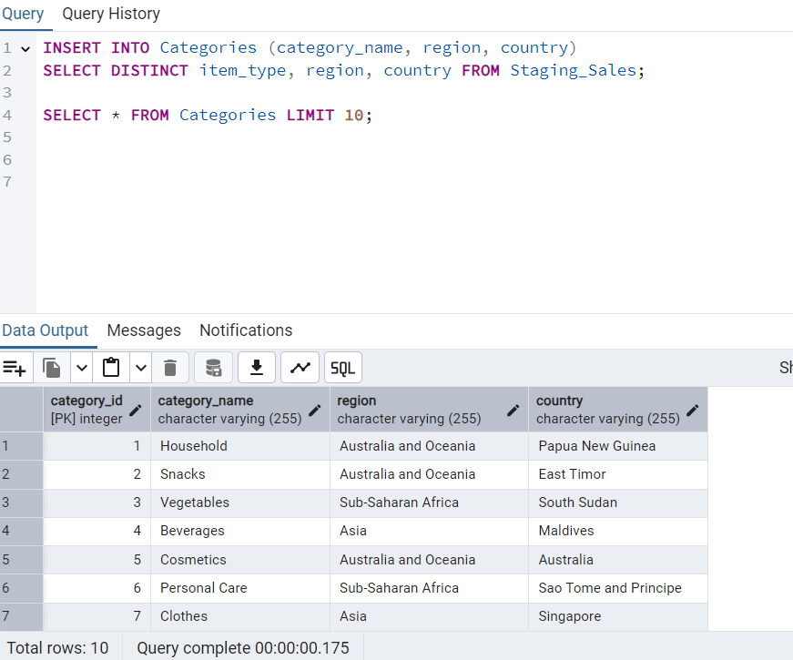
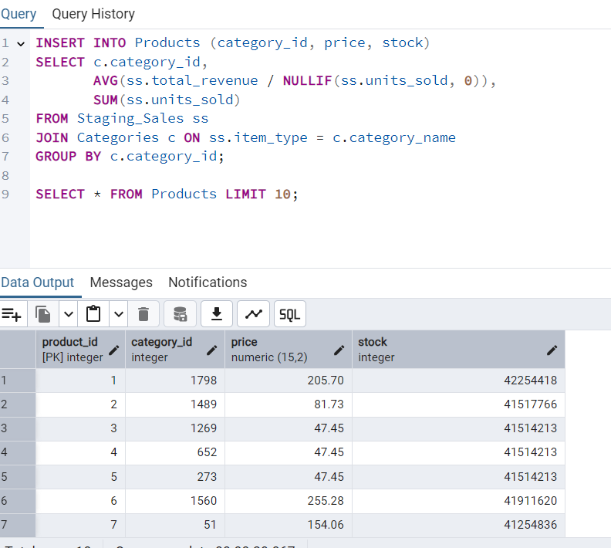
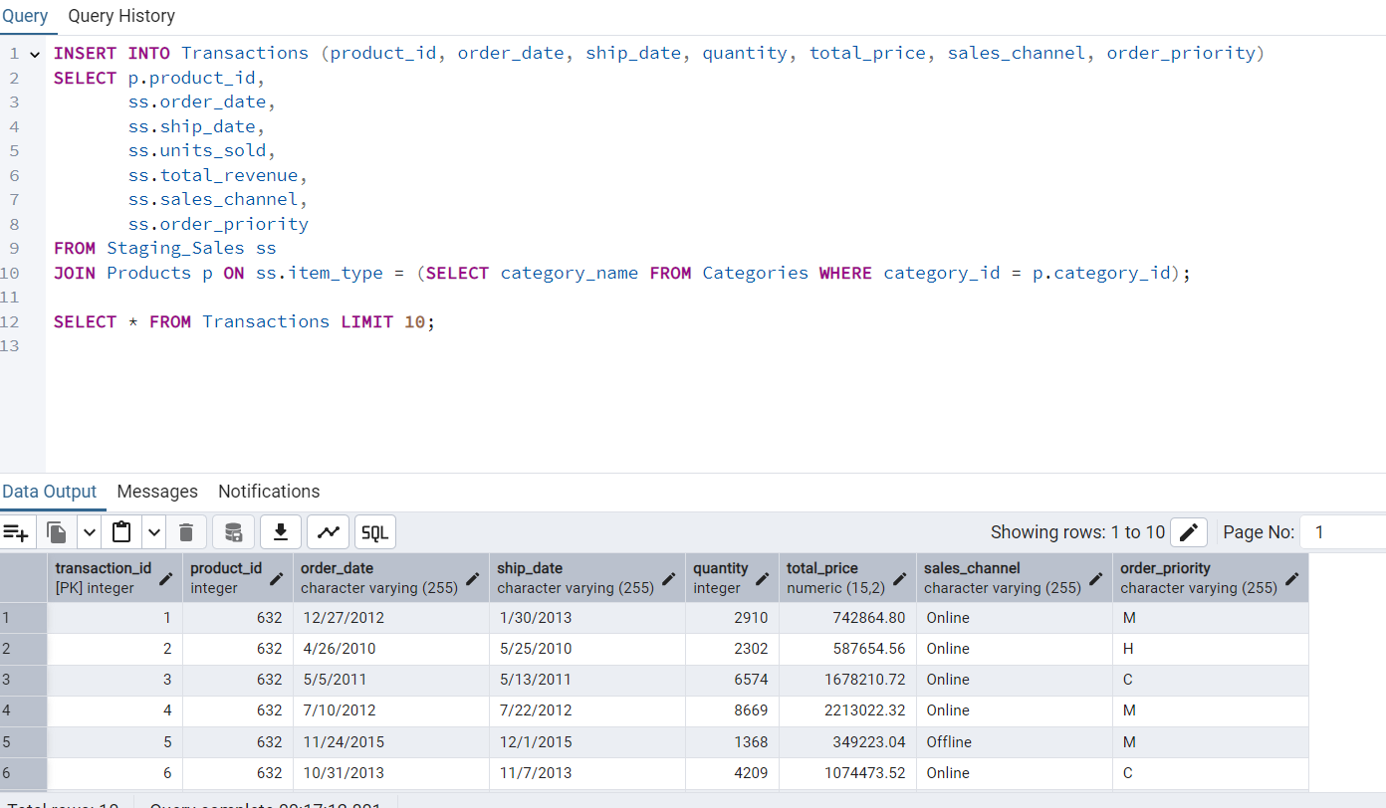

F3: Query Examples:
F3: Query 1 - Total Revenue by Region:
A query for Total Revenue by Region helps analyze which areas are performing the best or need improvement, so decisions about where to focus resources can be made. It’s useful for planning strategies, budgeting, and forecasting future performance, while also identifying potential growth opportunities in certain regions. This type of query can also support compliance, reporting needs, and provide insights for comparing performance against competitors, helping the business stay on track with its goals.
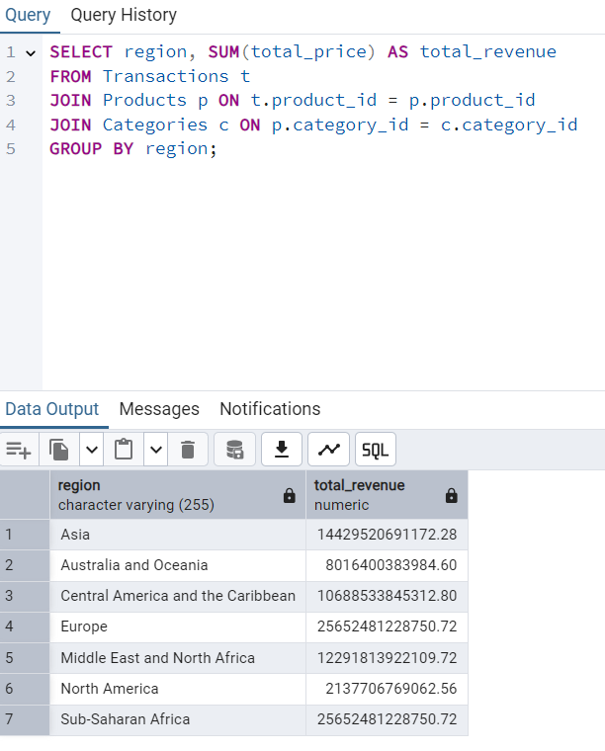

Before optimization:
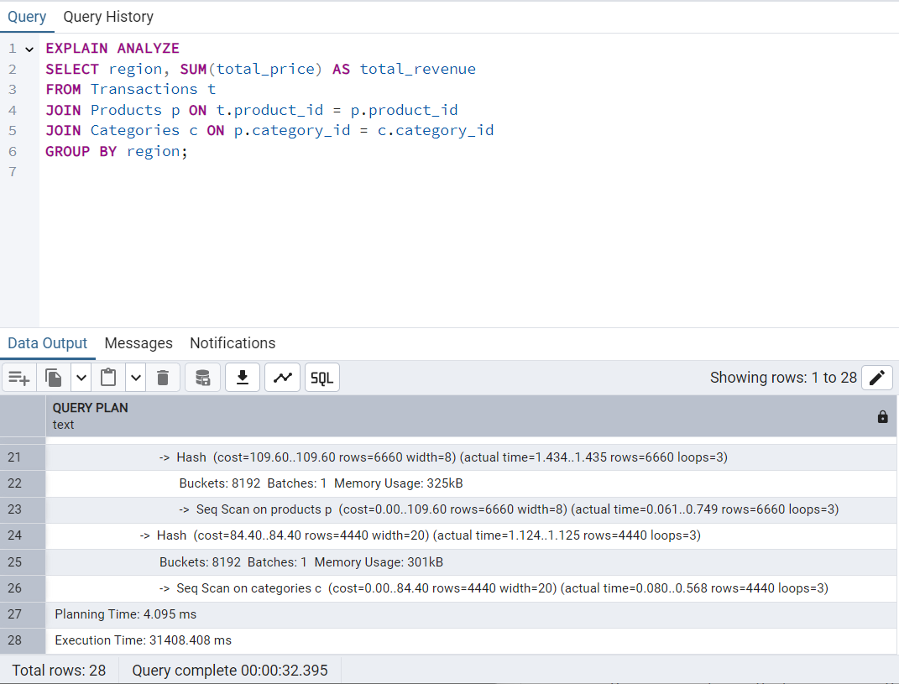

After optimization:
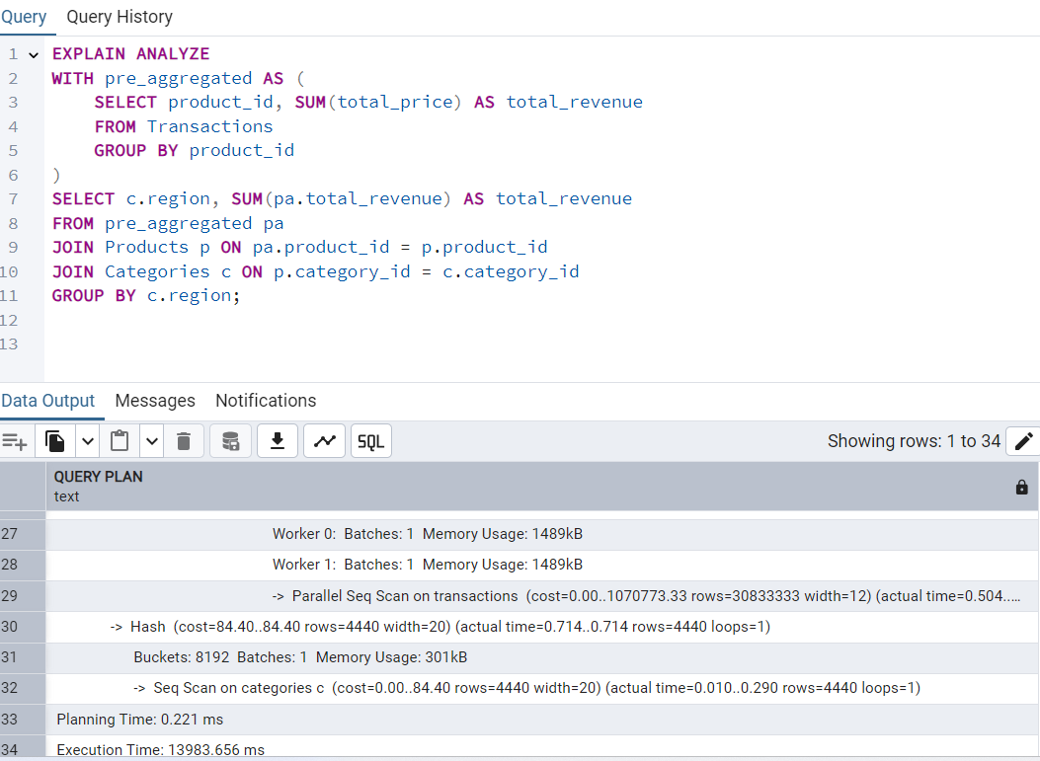
Runtime speed changed from 31408.4 ms to 13983.6 ms

F3: Query 2 - Top 5 Selling Products
A query for the Top 5 Selling Products helps identify which products are performing the best, giving insight into what customers prefer. This information is useful for making decisions about inventory, marketing, and production, ensuring resources are focused on the most profitable items. It also helps with forecasting future demand, planning promotions, and understanding trends. By knowing your top-performing products, you can drive more sales, increase profitability, and align strategies with what works best for the business.
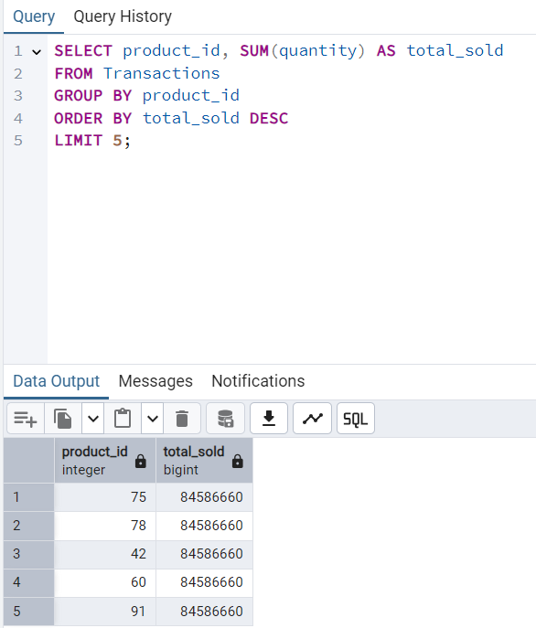
Before Optimization: 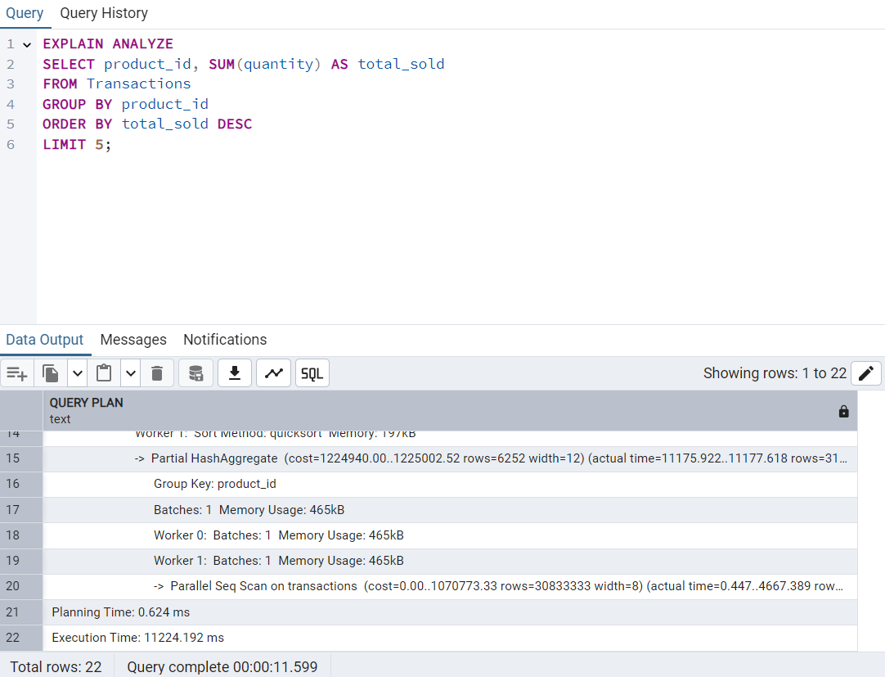

After optimization:
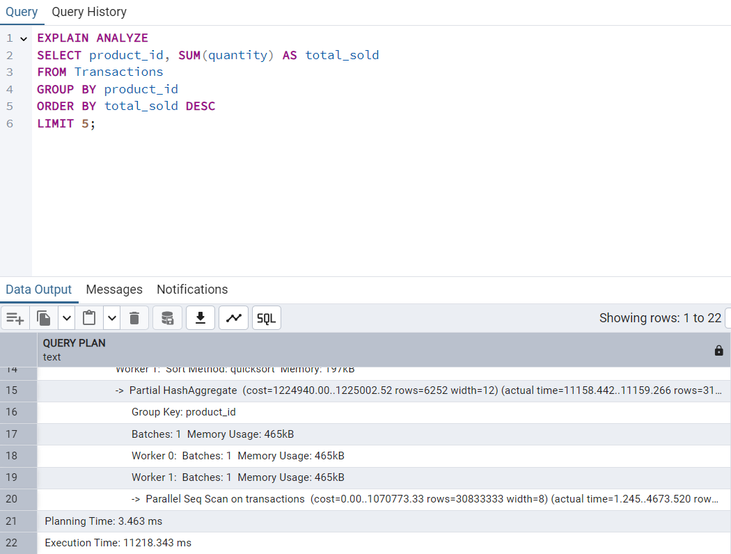
Runtime speed changed from 11224.1 ms to 11218.3 ms

F3: Query 3 - Analysis of Monthly Revenues
A query for the Analysis of Monthly Revenues helps track how the business is performing over time and spot trends or patterns in revenue. This information is useful for identifying peak sales periods, managing cash flow, and setting realistic goals for growth. It also helps in comparing month-to-month performance, forecasting future revenue, and planning strategies to address any dips or maximize high-performing months. Understanding monthly revenue trends is key to staying on top of the business’s financial health and making informed decisions.
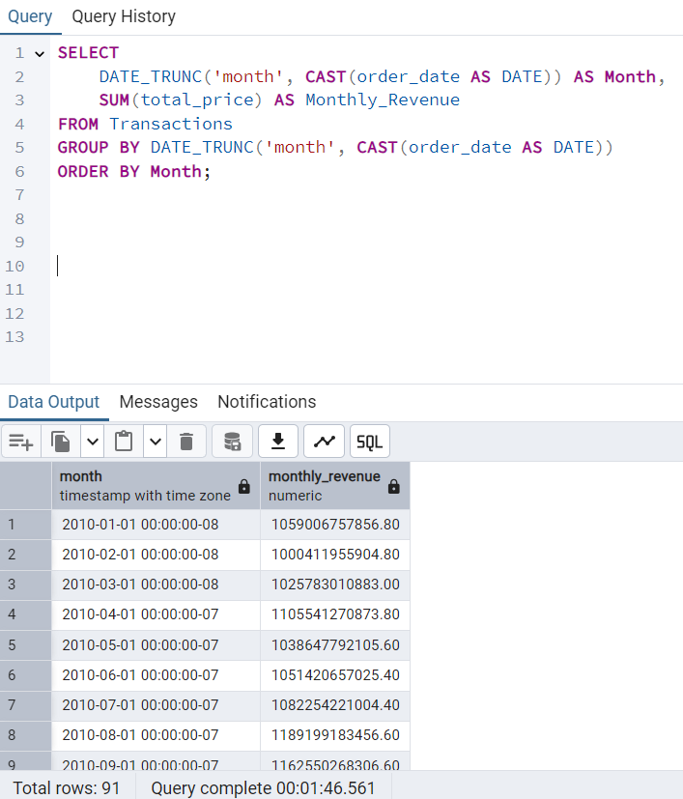
Before optimization:
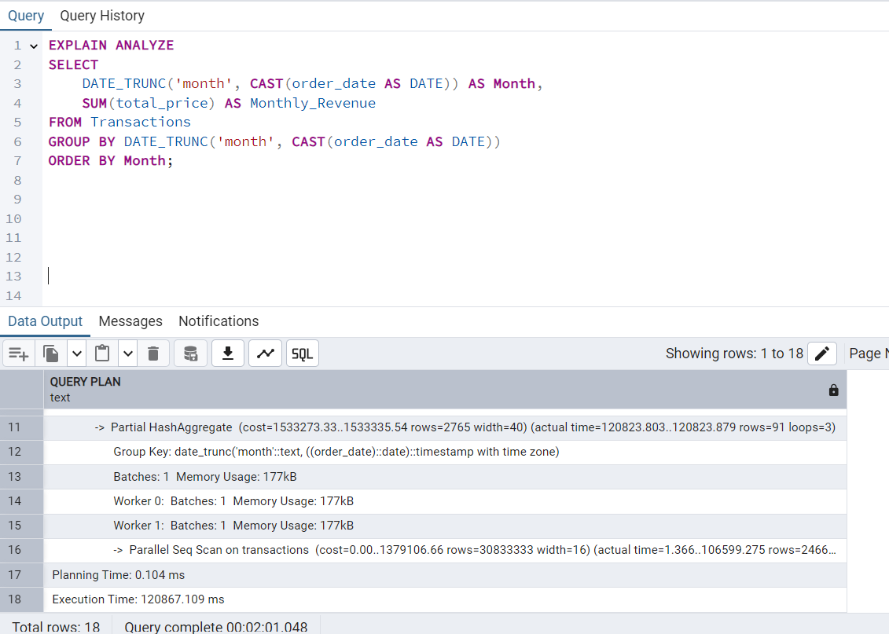

After optimization:
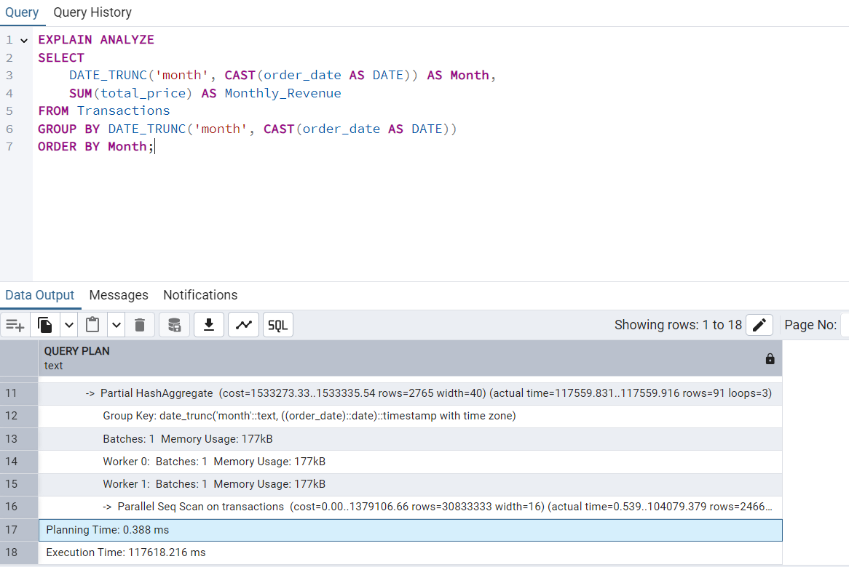
Runtime speed changed from 120867.1 ms to 117618.2 ms

F4: Optimization Techniques:
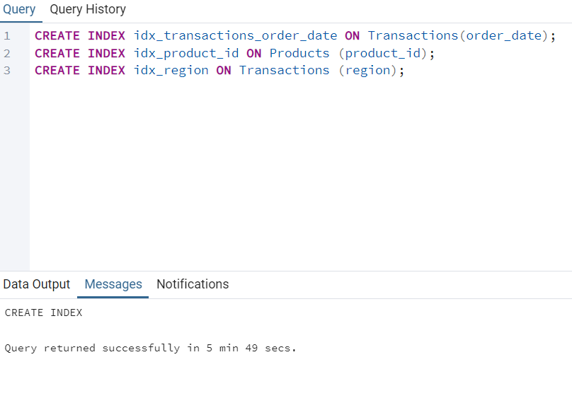

G: Panopto Video
H: Sources
No sources, web or otherwise, were used in the creation of the project and its follow up report.

